BMIT2154: Switching And Routing Technologies (July 2024 semester) 
TUTORIAL 1: SWITCHING CONCEPTS
1. Explain the two-step process that is performed on every Ethernet frame that enters a switch.
- Step 1 - Learn
  - Adds the source MAC if not in table AAA
  - Resets the time out setting back to 5 minutes if the source is in the table.
- Step 2 - Forward
  - If the destination MAC is in the MAC address table it is forwarded out the specified port.
  - If a destination MAC is not in the table, it floods out all interfaces except the one it received.
2. Layer 2 switches use two methods to forward frames.
a) List the TWO (2) methods to forward frames.
- Store-and-forward switching
- Cut-through switching

b) With the aid of diagrams, explain the differences between the two methods to forward frames.
- Store-and-forward switching
  - 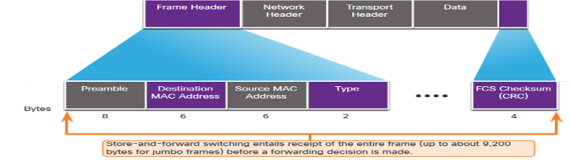
- Cut-through switching
  - 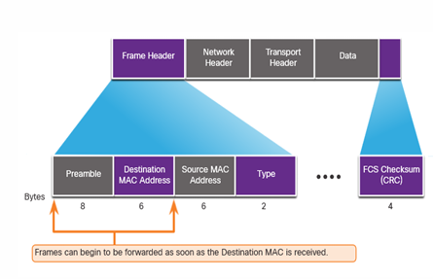
3. Refer to CISCO Netacad Switching, Routing and Wireless Essentials (SRWE), go through Module 2.1.8 Activity – Switch It. Refer to Figure 1.1 for an example of a question. Once you answered Question 1 and Question 2, click “Check” to check whether your answer is correct. Once you have completed the first question, click “New Problem” to attempt another question. You can proceed to try as many questions as possible. Your tutor will test your understanding during the tutorial class.
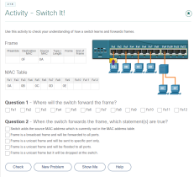
Figure 1.1 Example of a Question related to Frame Forwarding from CISCO Netacad SRWE
4. Source: Modified from Past Year Question 8 June 2023.
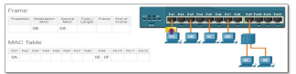
Figure 1.2 A Switch Frame Forwarding Diagram (Source: CISCO Netacad SRWE) a) Based on Figure 1.2, where will the switch forward the frame?
Port Fa3, Fa5, Fa7 and Fa9 will receive the frame. (flood out all the available ports except the port which send out the frame)
b) Explain how the switch forwards the frame to the destination device(s) based on Figure 1.2.

The OB address is not in the MAC table. Thus, the frame will flood out all the available ports except the port which sends out the frame.
1
BMIT2154: Switching And Routing Technologies (July 2024 semester)
5. Fill in the following table to differentiate between the function of a hub, Layer 2 switch and a Router in terms of segmenting a collision domain or a broadcast domain.
Device | Segment Collision Domain (Yes or No) | Segment Broadcast Domain (Yes or No)
Hub | No | No
Layer 2  Switch | Yes | No
Router | Yes | Yes

** Extra notes:
- Hub is layer 1 device which is a physical layer device. When there are more than 1 device sending frames to the hub, collision will happen. (like 2 cars in opposite direction on a 1 lane road)
- Switch is a layer 2 device. Every device has its own lane so collision can be avoided. (e.g. 3 device has 3 collision domain)
- Segment Broadcast Domain means dividing the broadcast domain.

6. Explain the term collision domain by relating to the network topology shown in Figure 1.3. Identify how many collision domains are in the network. Redraw Figure 1.3 in your answer and circle the collision domains. (Source: Modified from Past Year Question 8 June 2023)
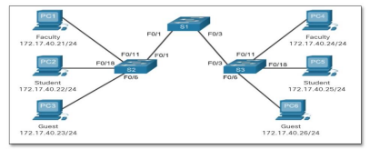Figure 1.3 Network Topology
8 collision domain
7. Based on the topology in Figure 1.4 and Figure 1.5, identify collision domains and broadcast domains by circling in the diagrams. In addition, indicate how many collision domains and broadcast domains using the network topology as shown Figure 1.4 and Figure 1.5. Redraw the network topology separately in your answer. Circle the collision domains and broadcast domains respectively.
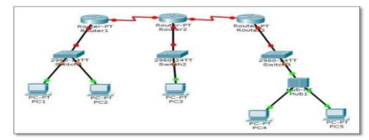Figure 1.4 Network Topology
9 collision domain (focus on switch port and router port) (hub does not support segment collision domain) (red color)
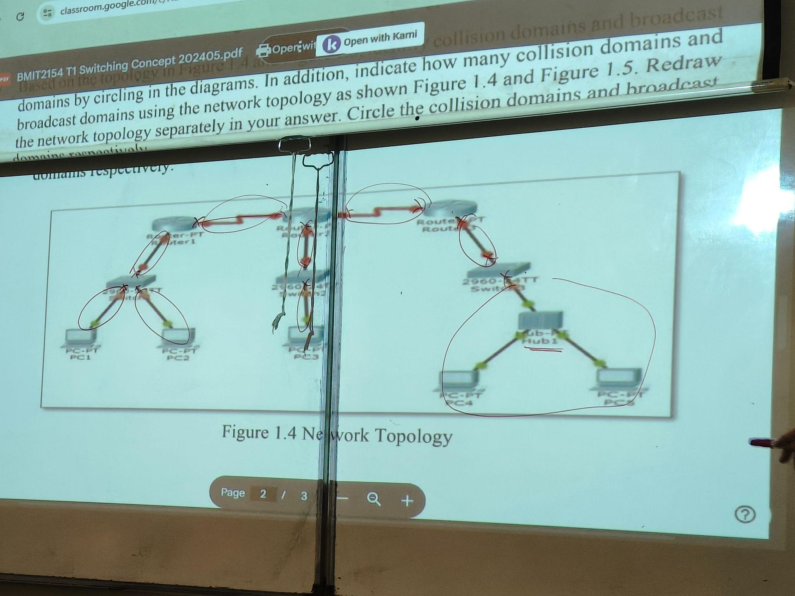
5 broadcast domain (focus on router port) (black color)
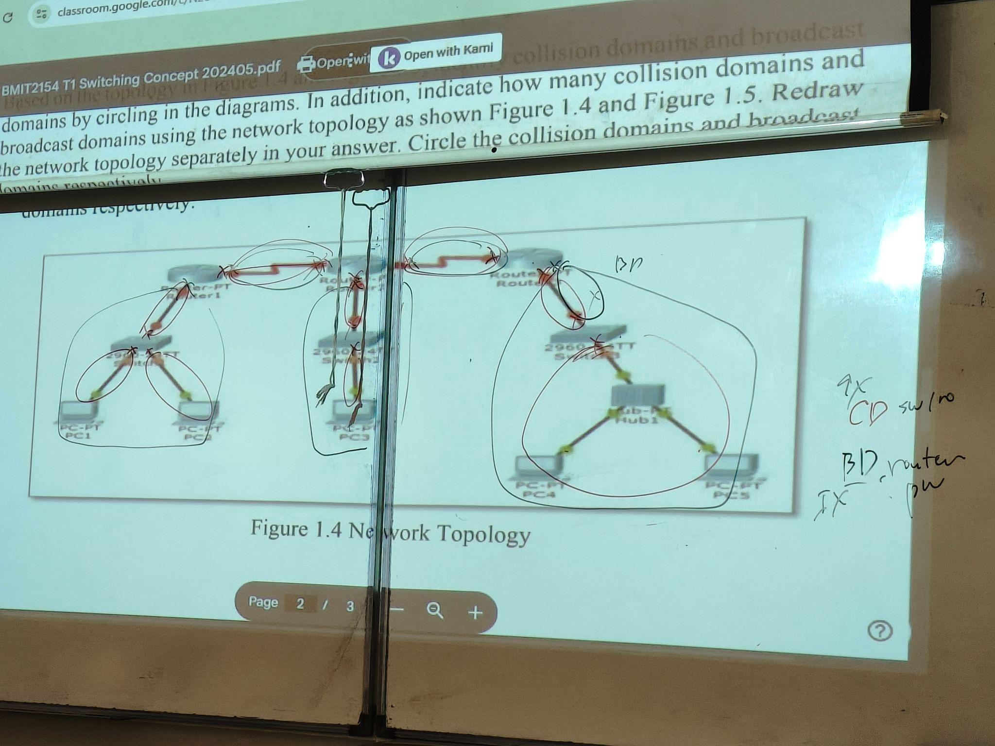
2
BMIT2154: Switching And Routing Technologies (July 2024 semester) 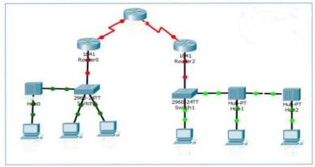
Figure 1.5 Network Topology
8. The following questions are based on the information shown in Figure 1.6. 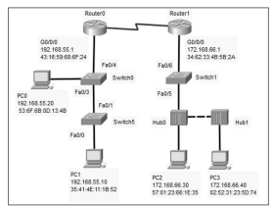
Figure 1.6 Network Topology
a) Identify the total number of collision domain(s) in Figure 1.6. Redraw the network topology in Figure 1.6 in your answer and circle the identified collision domain(s).
7 collision domains
* Need to redraw a simple diagram to show the circle.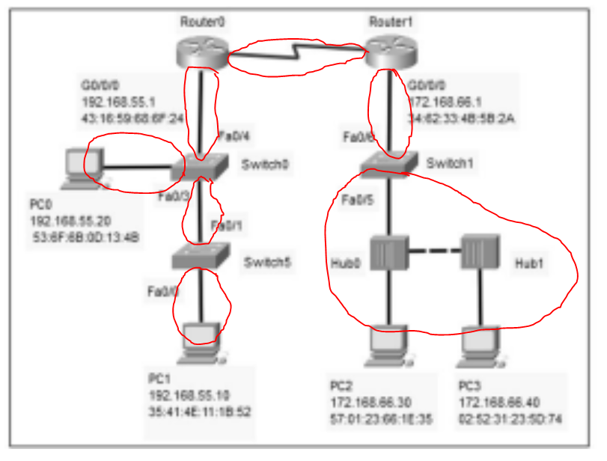

b) Identify the total number of broadcast domain(s) in Figure 1.6. Redraw the network topology in Figure 1.6 in your answer and circle the identified broadcast domain(s).
3 broadcast domains
* Need to redraw a simple diagram to show the circle.
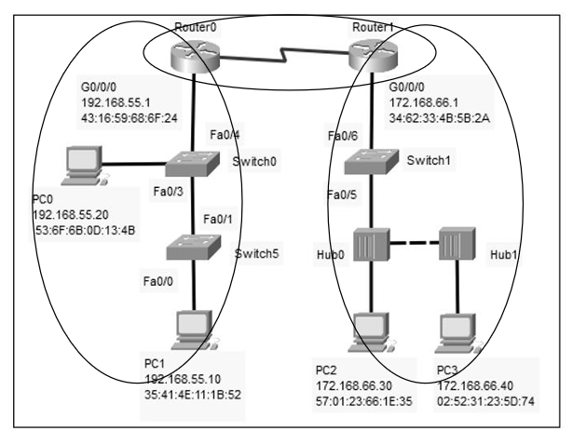
c) Tabulate a table to document the source IP address, destination IP address, source MAC address, and destination MAC address at PC1 when PC1 sends a frame to PC3 in Figure 1.6. Assume that the network is at a converged state.

Source IP Address  (sendiri) | Destination IP Address (end point) | Source MAC Address (sendiri) | Destination MAC Address (nearest router, default gateway)
192.168.55.10 | 172.168.66.40 | 35:41:4E:11:1B:52 | 43:16:59:68:6F:24

d) Determine what Switch0 will do when it receives a frame from PC0 and the Content Addressable Memory (CAM) table or known as MAC Address Table of Switch0 is empty in Figure 1.6.
The Switch0 will flood out(all available ports, except the port that received the frame) the frame to the port Fa0/3 and Fa0/4 and record down the source IP address.
3

